Abstract

Open Targets is a public-private partnership that aims to support for systematic drug target discovery and prioritization. It has created a public platform that integrates large collections of big datasets from human genetics and genomics studies, which has been served as a very useful data sources for drug development. However, the size and complexity of the whole genomic data has posed a big challenge for scientists to do data query and computation. In this term project, we have explored and compared a few database techniques from SQL to noSQL for modeling on the Open Target genetics data in order to provide prototyping and proof-of-concept of various data modeling and queries. We have developed a simple web application and used subsets of the data to compare the data ETL process and the response time of the data query. The goal is to demonstrate the feasibility and choices of database modeling in order to design and scale up the more demanding queries necessary for the complete big data sets.

Exploring and Comparing Database Modeling on Open Target Genetics Data from SQL to noSQL

**Zhang, Wenliang**

CS779 Advanced Database Management

2021 Fall Term Project

Table of Contents

1. Introduction to Open Target Datasets 3

1.1 Overview 3

1.2 Data Access and Description 3

1.3 Datasets used for prototyping 4

2. Explore and Compare Database modeling 5

2.1 Cloudera with Hive and impala 5

2.2 PostgreSQL 7

2.3 TileDB 8

2.4 MongoDB 11

2.5 MongoDB + Spark 13

3. Web Application Demo 14

4. Summary and discussions 14

5. SOURCES 15

# Introduction to Open Target Datasets

## Overview

Open Targets is a public-private partnership between industries and academia that aims to help life-science research scientists to identify and prioritize potential therapeutic drug targets. It has created a comprehensive open-source research platform that integrates a large range of publicly available datasets generated from human genetics and genomics studies.

There are two main data resources provided by Open Targets: **Open Target Platform** and **Open Targets Genetics Portal**. Open Targets Platform data focuses more on the broad range of biological data that are curated and summarized as evidence of target-disease association, with a score ranging from 0-1, while Open Targets Genetics Portal focuses on Genome-Wide-Association-Study (GWAS) and functional genomics data to enable large scale exploration and identification of causal variants and genes. It includes the disease-agnostic Variant-to-Gene (V2G) mapping and a disease-specific Locus-to-Gene (L2G) mapping for trait-associated loci, both of which summarize the results as a score ranging from 0-1. It also includes colocalisation analysis between studies and diseases.

## Data Access and Description

To access the Open Targets data, you can query data either through the web interface manually or access through their API programmatically. However, both methods are not ideal for doing analysis at a very large scale, where the queries are getting bigger and more complex and may require the whole data table from the database. So in order to harness the data better being able to query data in a more flexible way and at a larger scale, I decided to download the whole datasets, and explore various options for database modeling. The current version of the whole Open Target Genetics data size is about 1.2 Terabytes, mostly in JSON and parquet format. The description, size and format information of the complete Open Target Genetics datasets are listed in the table as below:

|  |  |  |
| --- | --- | --- |
| Dataset | Description | Size(Format) |
| d2v2g | Intersection table linking studies to variants to genes | 700 Gb (JSON) |
| l2g | Locus to gene scores and subscores | 500 Mb (csv) |
| sa_gwas | Summary statistics for GWAS studies | 120 Gb (parquet) |
| sa_molecular_trait | Summary statistics for molecular trait studies | 35 Gb (parquet) |
| v2d | Data linking variants to studies | 10 Gb (JSON) |
| v2d_coloc | GWAS-GWAS and GWAS-molecular trait colocalisation results | 2 Gb (JSON) |
| v2d_credset | Fine mapped credible sets for all GWAS | 2 Gb (JSON) |
| v2g | Data linking variants to genes from V2G pipeline | 251 Gb (JSON) |
| variant-index | Variant index | 45 Gb (JSON) |
| genes-index | Gene index | 12 Mb (JSON) |
| study-index | Study metadata including trait, publication and ancestry information | 10 Mb (JSON) |
| overlap-index | Pair-wise overlap between all independently associated GWAS loci | 1 Gb (JSON) |

## Datasets used for prototyping

In order to prototype and compare the database modeling, in this project I have chosen three datasets, v2d_credset, variant-index, and study-index for my database modeling experimenting process. The study table contains various information about each GWAS Catalog study. Each study has a unique study_id. The credset is the finemapping table containing Credible set anlaysis results used to link index (or lead) variants to tag variants. Variants table has all the information about each variant.

The information about each dataset is listed as below:

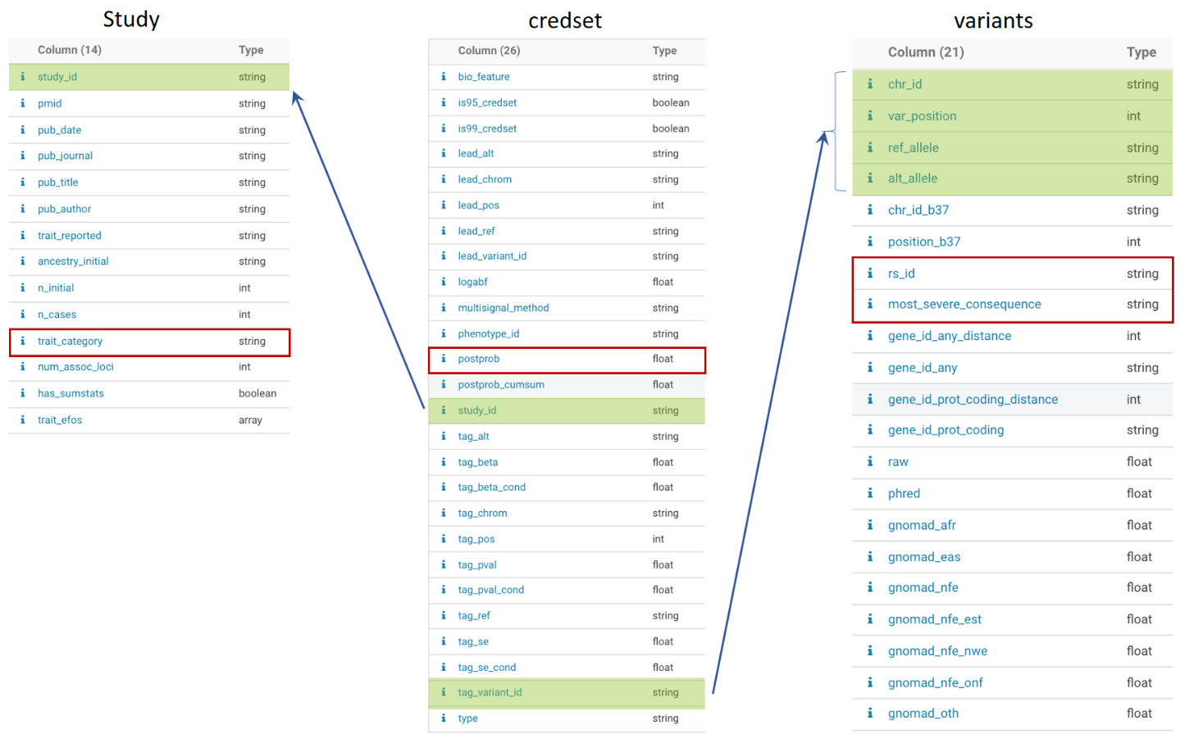

The complete datasets are used for the implementation on the big data Cloudera platform while only the subsets of the three datasets were used as the test datasets for prototyping on other database software platforms in order to speed up the iteration of the development cycle. The subletting process is done on the HDFS on Cloudera platform using Hive (For details, please refer to session 2.1).

A data query is designed to validate the performance of the joined operations on each platform based on the time cost to get the query results. The objective of the query is to find coding variants with high posterior probability for a certain trait category of interest.

# Explore and Compare Database modeling

The following database software platforms have been explored in this project. We have compared the data modeling, data ETL process as well as the performance of the designed joined query. The platforms include the following:

1. Big data platform, Cloudera Hadoop HDFS system with Hive and Impala as the query engines
2. DBMS PostgreSQL
3. A newly emerged array-based database called TileDB
4. Document based noSQL solution using MongoDB
5. Lastly the combined solution using MongoDB and pySpark

## Cloudera with Hive and impala

Cloudera is the commercial version of Hadoop ecosystem with many useful big data tools such as, Spark, Hive and Impala. The biggest advantage of using Cloudera with Hive and Impala is that you can use the schema on the read, which means that you don’t have to design the schema beforehand. That is to say that we can save all the raw data in the data lake, for example, AWS S3, and then design the schema and write meta into HDFS meta store.

Hive and Impala are the tools that allow you to write SQL like script to do interactive big data query from a distributed data system. The language of Hive and Impala is very like SQL, so you don’t have to learn a completely new language in order to use. Behind the hood, Hive is using the map-reduce jobs that are executed and processed on the Hadoop system while Impala has its own algorithm of processing the data. Compared to Hive, Impala generally performs faster but more memory intensive and does not support fault tolerant as it is not using the map-reduce algorithm like Hive does. Also Hive support more complex data type. Therefore, Hive is more suitable for batch data query and processing, while Impala is more appropriate for interactive data query and exploration or small datasets processing. Here below is the diagram of the architecture summarizing how the Hive and Impala query works.

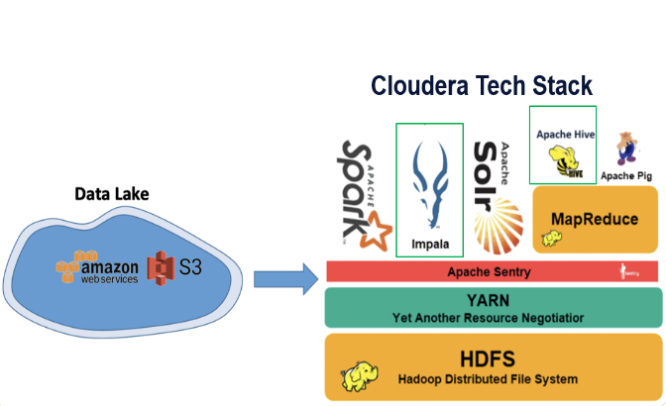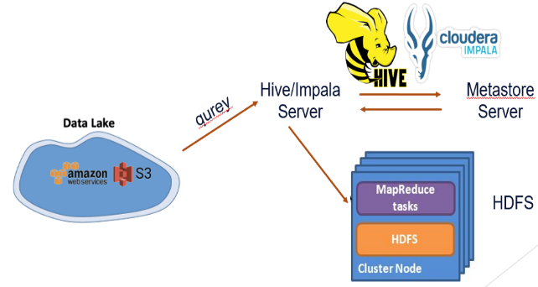

Here is the example query to get variant and study information for the credset of high posterior probability.

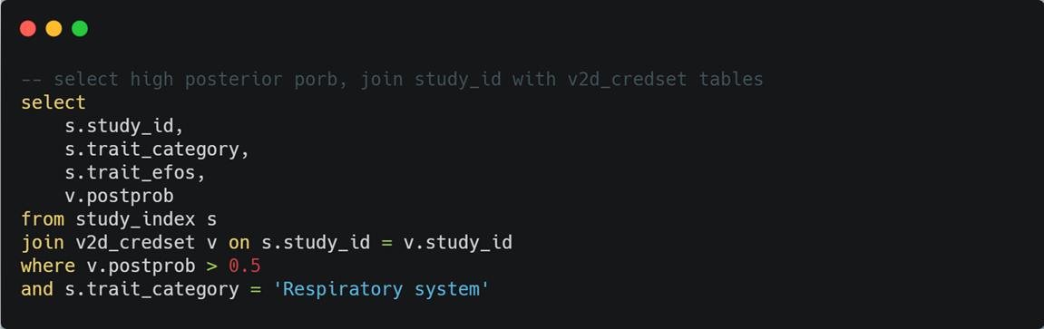

In order to explore and prototype using other database management system, the following HIV SQL script was used to subset the three dataset by filtering the data on the column of trait_category of the study table to contain only the three categories: Respiratory System, Immune System and Nervous System. The query is performed on the HUE (Hadoop User Experience). Below is the screenshot of the script and the query results. The query takes about one and half minutes to finish. After subset and data cleaning, we are able to reduce the size of test dataset significantly.

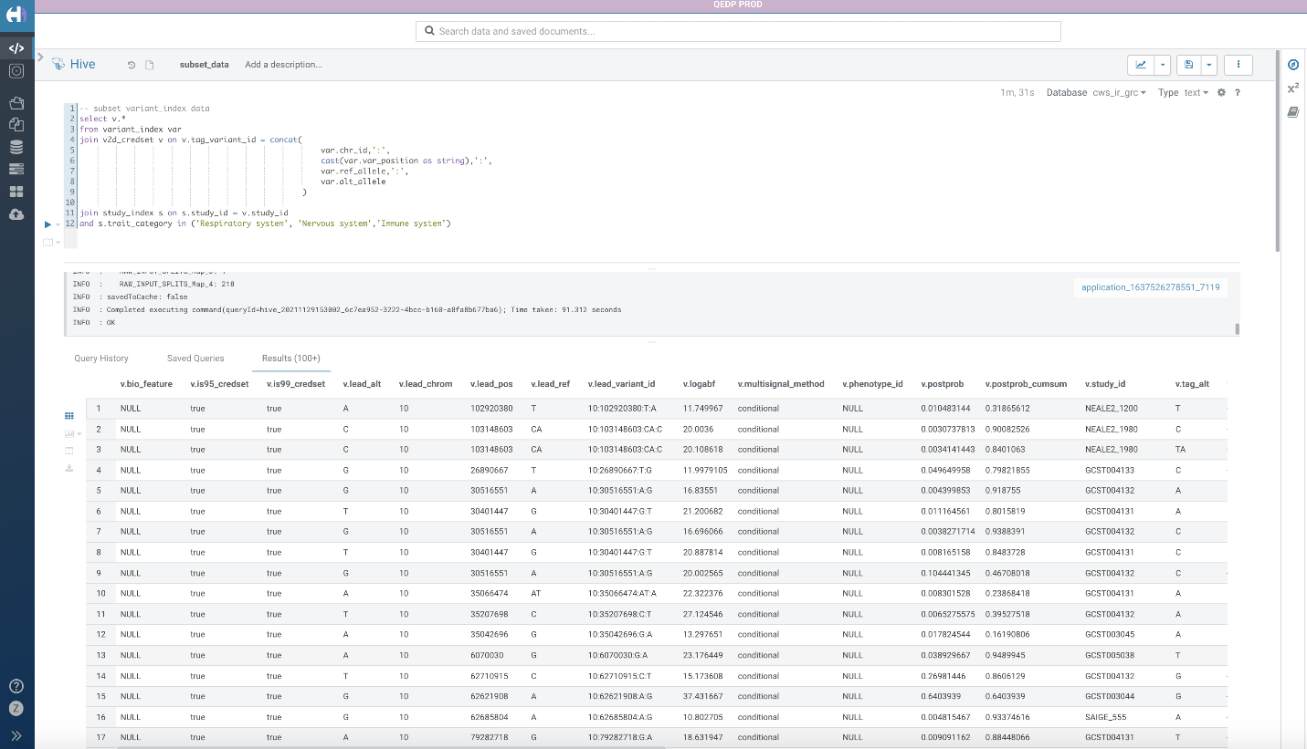

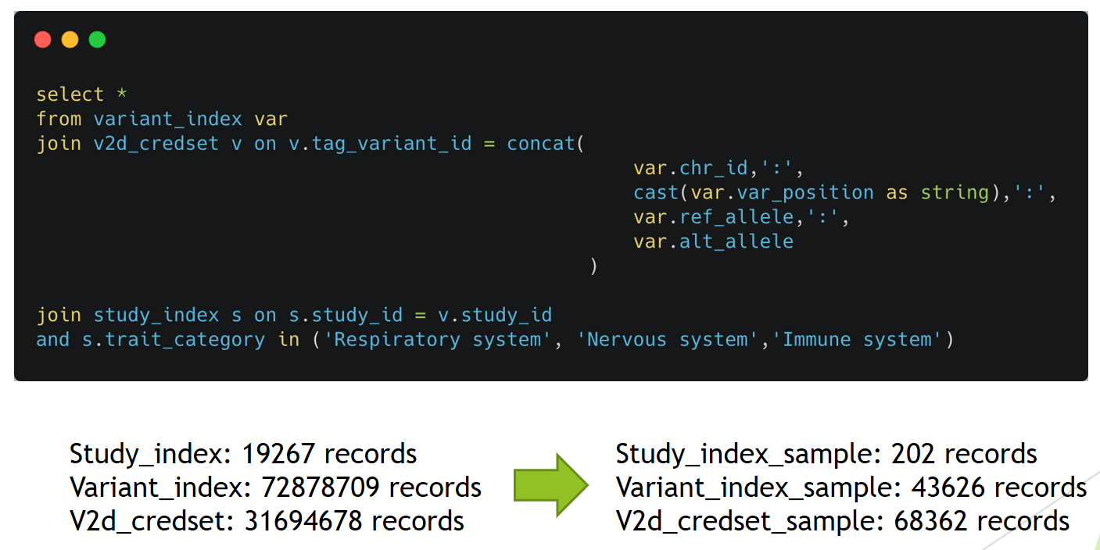

## PostgreSQL

We started to model the test datasets from the relational database management system, PostgreSQL. We read the sample dataset in csv format using Python pandas and did some data cleaning to get rid of some non-essential information. The viaraint_id field was created and used as the primary key for the variant table. The data sets were injected into the database using Pandas dataframe and sqlalchemy package. Then the primary and Foreign keys and Index were created. The code is as below:

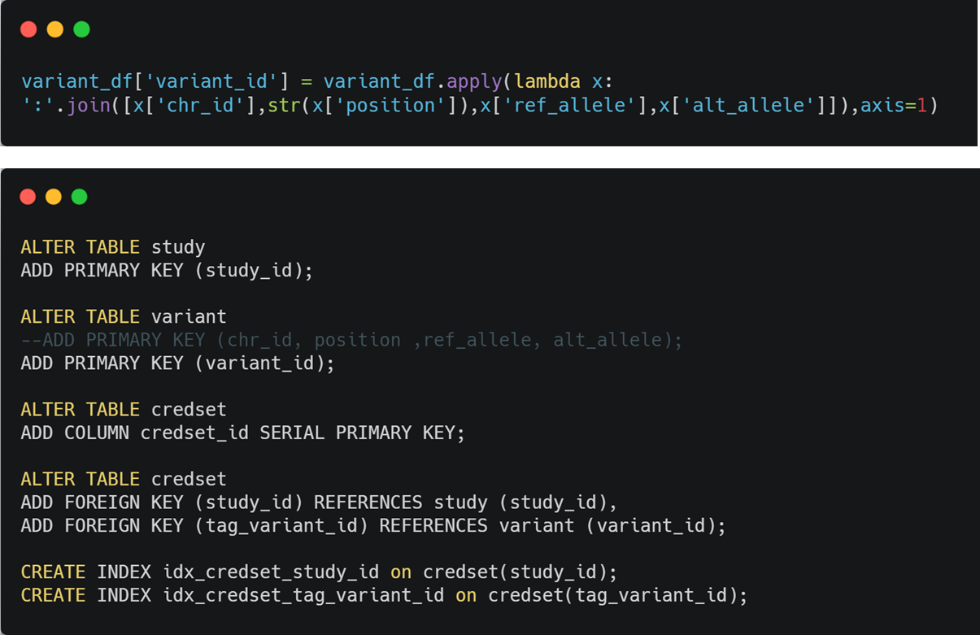

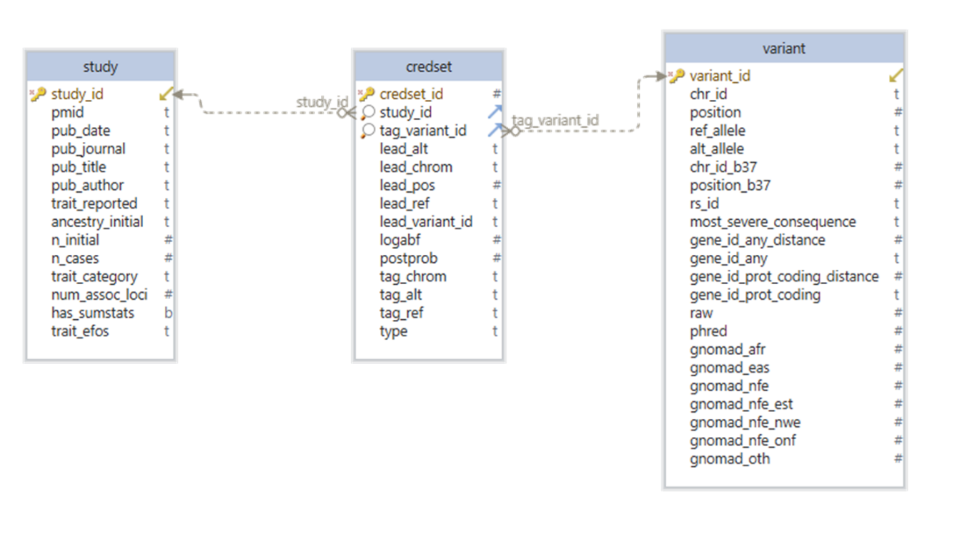After we created the primary and foreign keys for all three tables, the schema looks like below:

To test the performance of our joined query, we executed the query command using our web application. The query time shows that it is performing very well with less than 1 sec with our test datasets. The snapshot of the web application and query results are shown below:

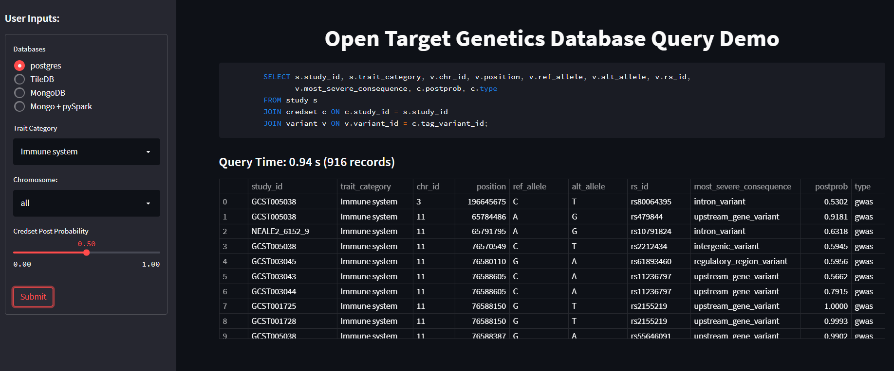

## TileDB

TileDB is a universal data storage engine architected around multi-dimensional arrays that enables storing and accessing data using Dense or Sparse arrays data models. It has the following key features:

* Native cloud object storage and access
* Read/write queries are fully parallelized
* Multi-dimensional indexing
* Query times grow with result not data size

Build study TileDB array using Python API:

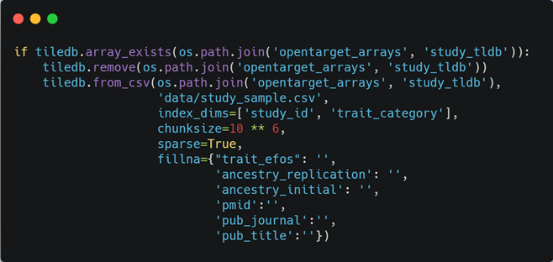

Here is the simplified diagram showing how the example study TileDB array look like.

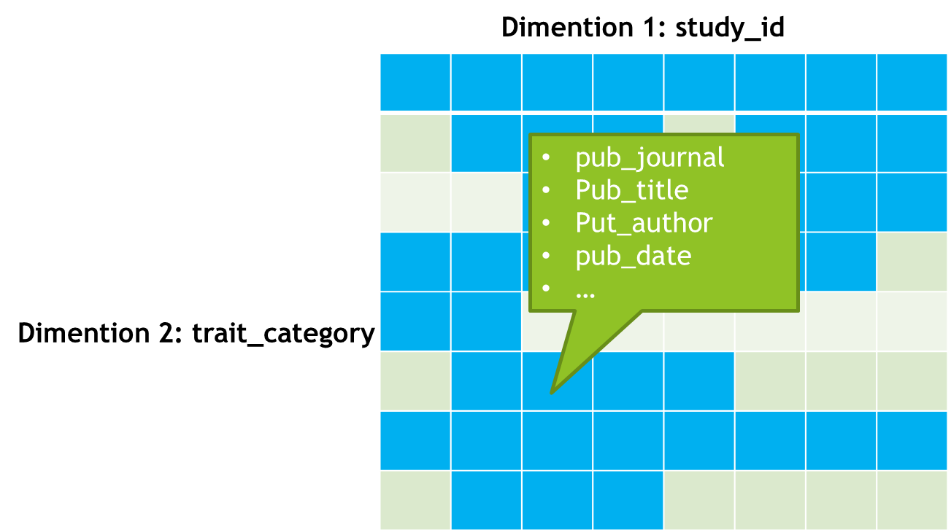

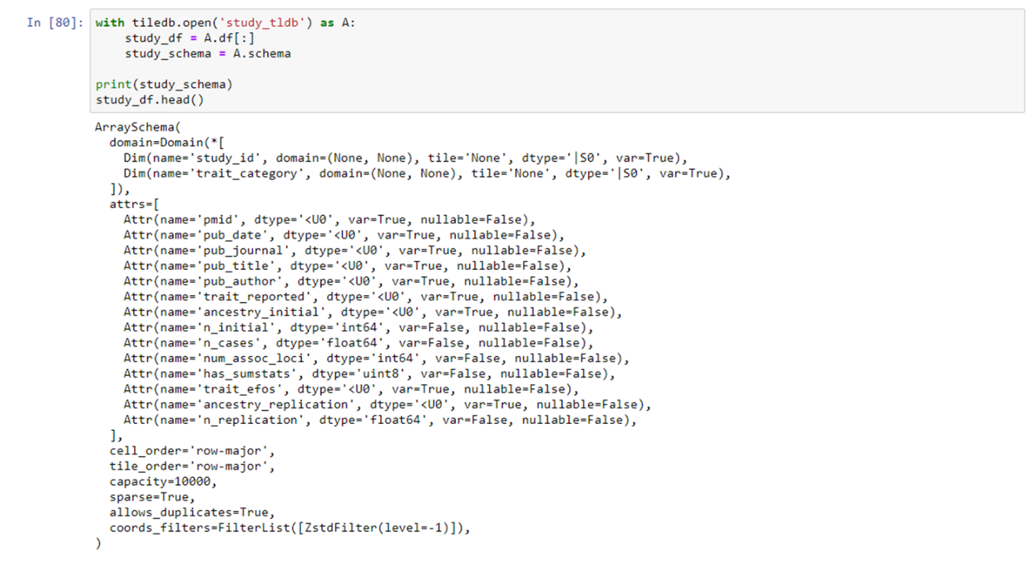

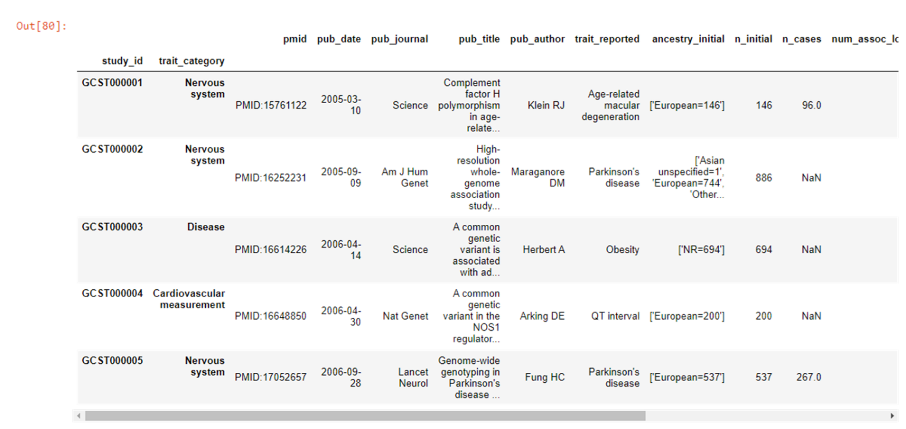

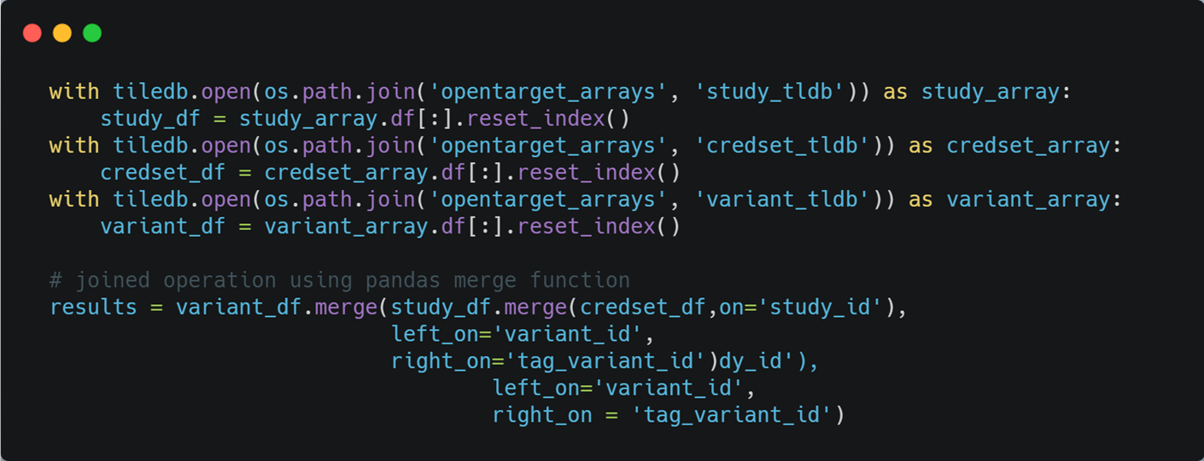

## MongoDB

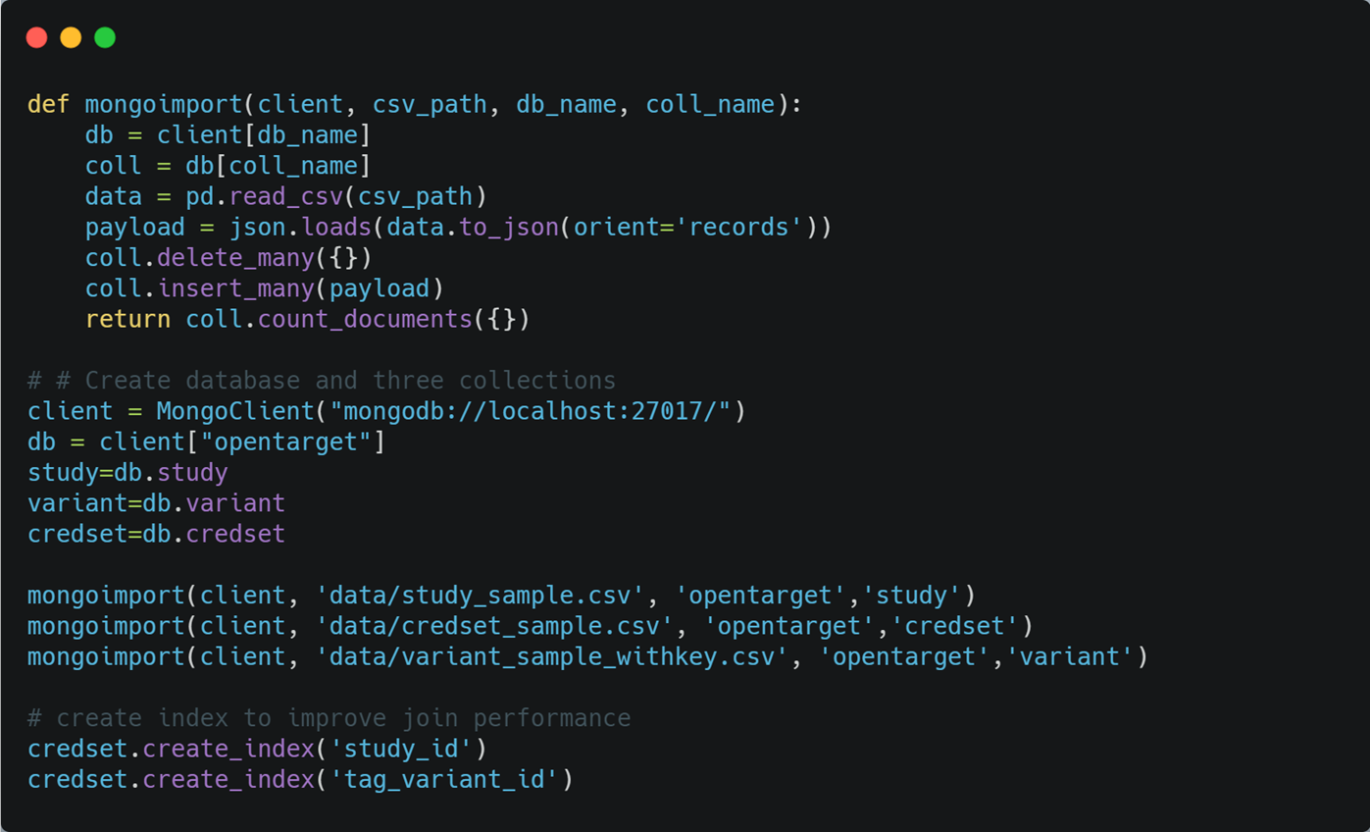Inject the data into MongoDB

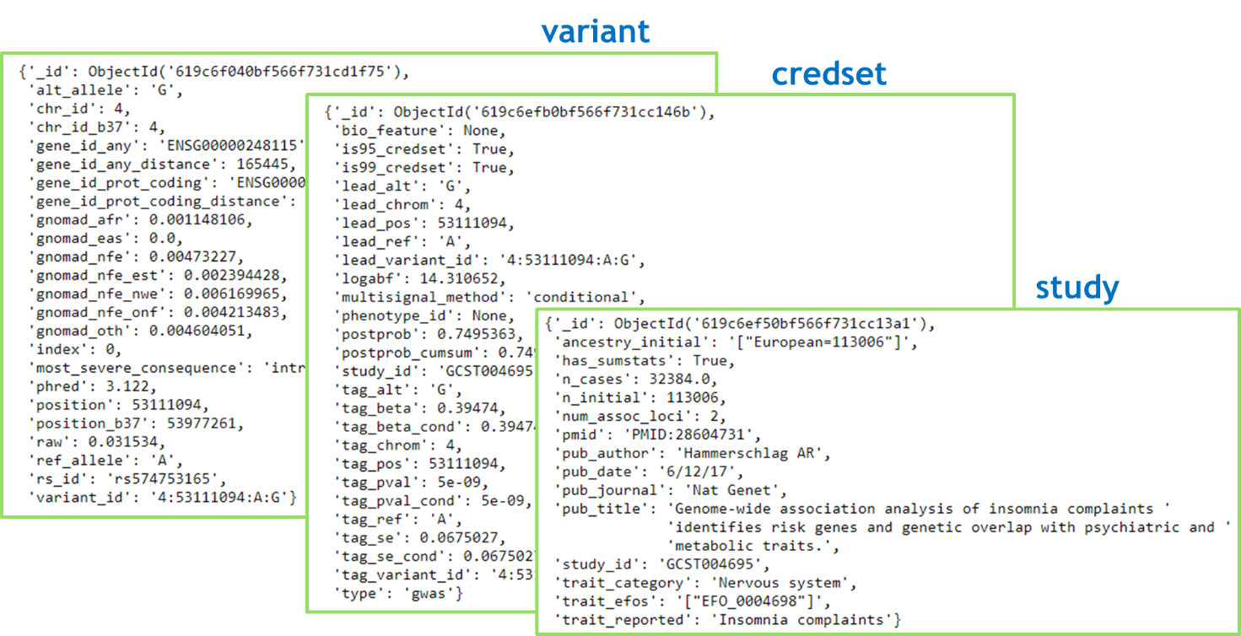

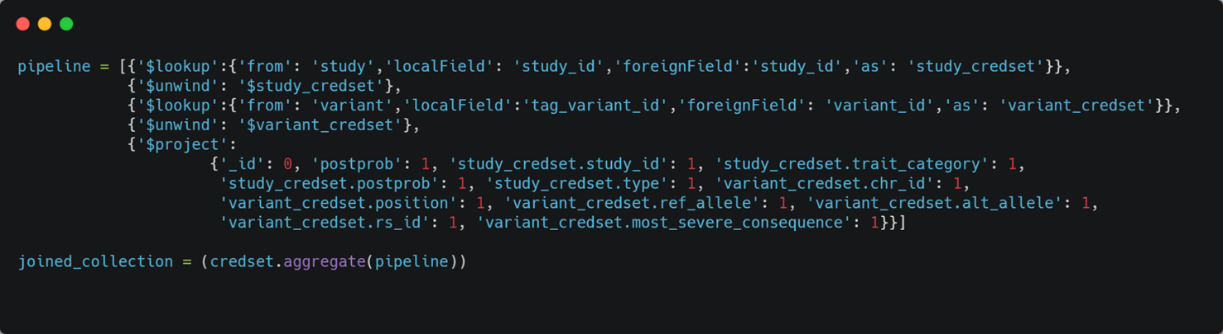

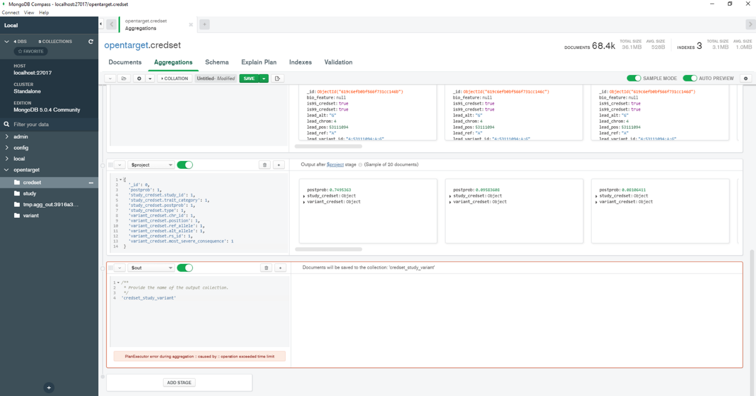

## MongoDB + Spark

Read Data from MongoDB into Spark DataFrame:

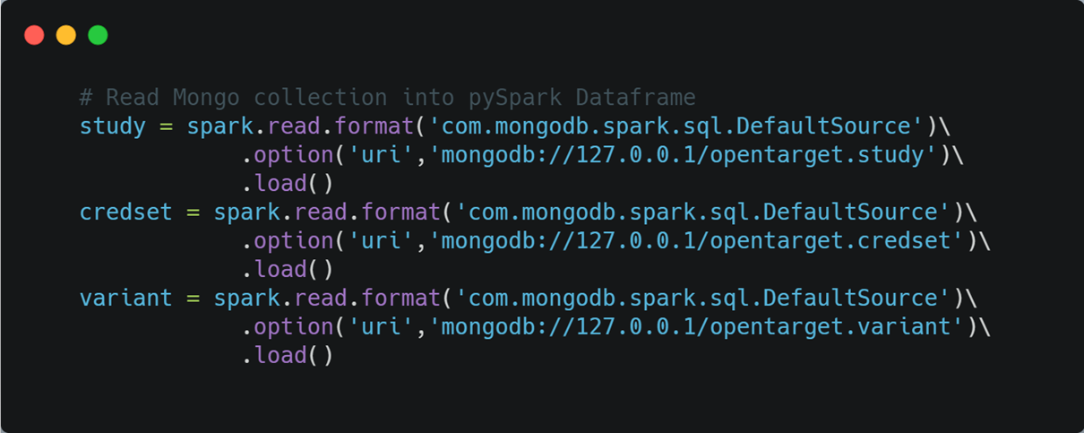

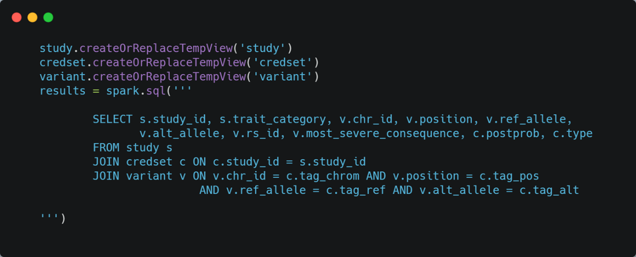

# Web Application Demo

# Summary and discussions

In summary, 1) HDFS and Hive/Impala is good for storing big data in the cloud. The raw data can be stored in S3 with infinite space. We can take advantage of the schema on read providing the most flexibility, however, the platform lacks some analytic functions. 2) For PostgreSQL, it is a little time-consuming for data preprocessing and designing schema in order to inject data into the database. However, the data query speed is the fastest among all database choices for the test datasets. 3) For TileDB, it has good concept on big data storage and slicing; native distributed data storage in cloud. However, during the implementation, I had met a lot of bugs. Considering the short history, it is reasonable that it is still pretty buggy at this stage, especially data type support and compatibility issues with Python and Spark. A big caveat I think is that the data slicing and feature filtering are optimized within the array. For the joined operation between arrays seem to be dependent on other framework, like Pandas/MariaDB/Spark. 4) For MongoDB, it is very easy to inject JSON and CSV data into database. But it was really a pain to perform join operations between collections and speed is very slow! 5) The final option using MongoDB + pySpark, which is the distributed data storage and big data analytics. SparkSQL can complement the aggregation and analyze function of MongoDB. It has a lot of potential for working on the complete Open Target Datasets.

Big data analytics face challenges at every stage of the pipeline, from data storage, data ETL, data analytics and visualization. There are also many tools at each stage for data engineers and analysts to choose. The database solutions discussed in this project are exploratory and preliminary, and may be serve as non-exclusive examples of database implementation for other type of datasets.

Open Targets Platform and Genetics Portal is still pretty new, but an innovative and evolving big data platform for severing life science community. The current data architecture has the multiple components including databases and big data tools that deserve dedicated full-time jobs to learn and improve. Here are the brief summary points I got from the job description and requirements for the Technical Project Lead (Open Targets) position posted online. I think it is a very good summary of the technical skills for the position as well as for the platform.

* Scala and Spark for ETL pipeline
* Data is injected into ElasticSearch and ClickHouse
* Data is served in the front end using GraphQL APIs using Play framework and consumed by React-based web interface
* All applications are deployed and served in Google Cloud Platform using Terraform
* Besides all above, all resulting datasets are made available to public through different channels using Google BigQuery

# SOURCES

1. Open Targets: <https://platform-docs.opentargets.org/>
2. TileDB documentation: <https://docs.tiledb.com/main/>
3. pySpark SQL documentation: <http://spark.apache.org/docs/latest/api/python/getting_started/quickstart_df.html>
4. pyMongo: <https://pymongo.readthedocs.io/en/stable/tutorial.html>